**Games Design**

**THE HANDBOOK**



**Course Ethos**

To provide a high standard of motivational, inspirational education in a real world context in an innovative, exciting and active environment through a nationally recognised vocational qualification with unique opportunities to allow learners the opportunity to succeed in their chosen path.

**The Creative Media Team**

Curriculum Leader for Creative - Alex Brewster ([a.brewster@thestudio-liverpool.](mailto:a.brewster@thestudio-liverpool.)co.uk)

Learning Coach for Creative Media – James Phillips ([j.phillips@thestudio-liverpool.co.uk](mailto:j.phillips@thestudio-liverpool.co.uk))

I.V. for yr12 Creative Media - Alex Brewster and James Phillips

I.V. for yr13 Creative Media - Alex Brewster and James Phillips

Lead I.V. for Level 2 Creative Media – James Phillips

Lead I.V. for Level 3 Creative Media – James Phillips

Behaviour Manager – Paul Donaldson ([p.donaldson@thestudio-liverpool.](mailto:p.donaldson@thestudio-liverpool.)co.uk)

**Course Timetable**

The course is seventy eight weeks long (78 weeks) with each year containing thirty-nine weeks. There are five sessions per week at one hundred minutes per session.

There are three hundred and ninety (390) sessions in total.

You will be required to do some work outside of class time.

**Course Structure**

The course is made up from 4 Mandatory Units and 6 Optional Units from the   
Pearson BTEC Level 3 National Diploma in Digital Games Design and Development suite.

*Mandatory Units*

Unit 3 Digital Media Skills External Assessment

Unit 7 Media Enterprise Internal Assessment

Unit 8 Responding to a Commission External Assessment

Unit 13 Digital Games Production Internal Assessment

*Optional Units – all Internal Assessment*

Unit 32 Concept Art

Unit 34 Game Engines Scripting

Unit 40 3D Modelling

Unit 41 3D Environments

Unit 42 Games Testing

Unit 43 3D Digital Animation

**Exam Board**

The awarding body for this qualification is **Pearson Edexcel**

**Skills Developed Over The Course**

Communication Skills Presentation – Verbal - Written

Leadership Project management techniques (AGILE / SCRUM)

Coding C# or JavaScript with Unity, 2D Games, 3D Game Demos

Literacy Written Assignments/Proofreading, Scriptwriting, Narrative Construction

Numeracy Financial budgeting, Scaling Up, Profit and Loss, Predicted Sales

Entrepreneurial Pitching Ideas, Working with Industry, Networking Events

Diplomacy Multi-disciplinary teamwork, Constructive Criticism,

Art/Drawing 3D Modelling, Ideas Generation, Concept Art, Box Covers, Posters, Icons, Sprites.

Design Character, Environment, Weapons, Objects, UI, UX, Games Mechanics

Quality Assurance Games Testing, User Testing, Pre-Alpha, Alpha, Beta,

Research Primary, Secondary, Qualitative, Quantitative, Market Research, Project Viability

**Studio KPIs**

Just like in industry our students have KPIs to work towards. Consisting of 4 different levels (Beginner, Apprentice, Expert and Coach) each section has been developed with industry to ensure our students not only have the technical skills to survive in the work place, but also the softer skills.

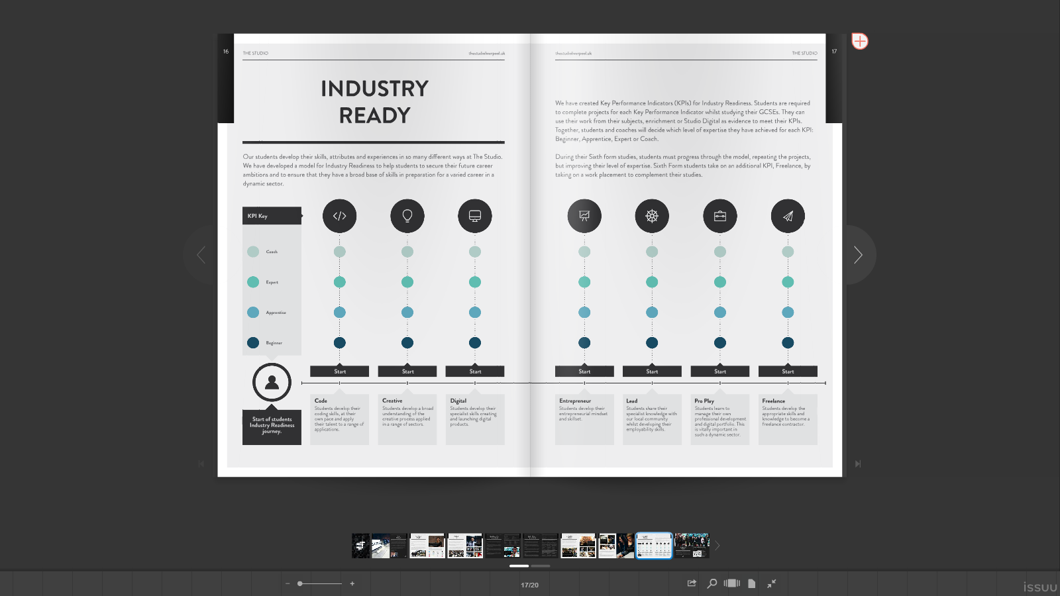

**Process of a BTEC Course**

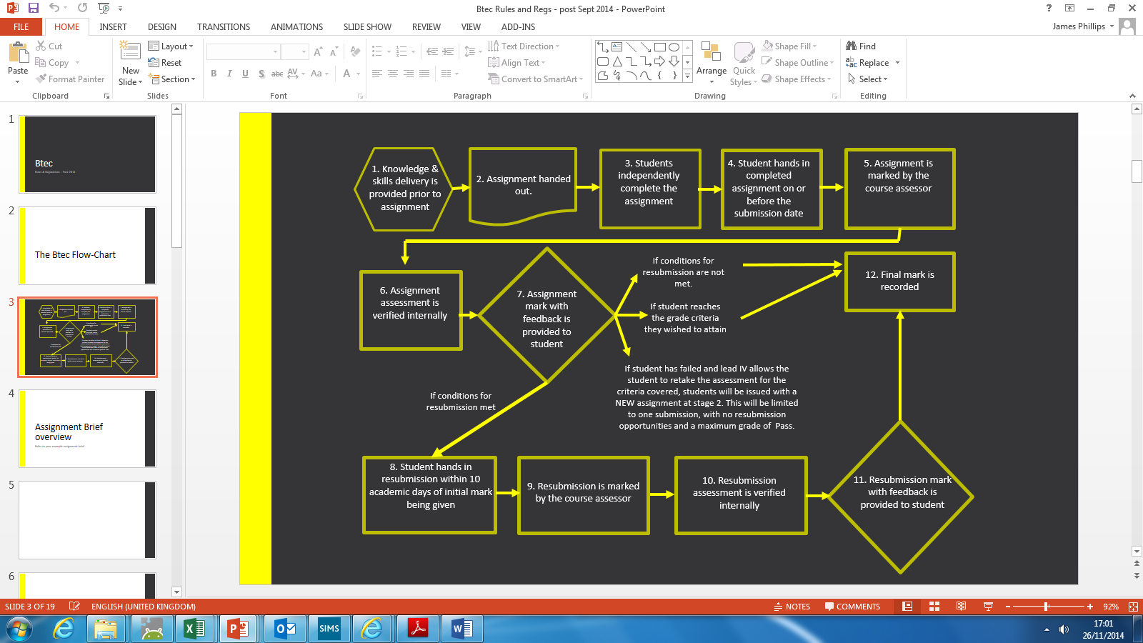

1. Knowledge & skills delivery is provided prior to assignment

2. Assignment handed out.

3. Students independently complete the assignment

4. Students hand in completed assignment on or before the submission date

5. Assignment is marked by the course assessor

6. Assignment assessment is verified internally

7. Assignment mark with feedback is provided to student – go to 12.

**If conditions for resubmission met**

8. Student hands in resubmission within 10 academic days of initial mark being given

9. Resubmission is marked by the course assessor

10. Resubmission assessment is verified internally

**12. Final mark is recorded**

If student has failed and lead IV allows the student to retake the assessment for the criteria covered, students will be issued with a NEW assignment at stage 2. This will be limited to one submission, with no resubmission opportunities and a maximum grade of Pass.

11. Resubmission mark with feedback is provided to student

**If conditions for resubmission are not met – go to 12**

If student reaches the grade criteria they wished to attain – go to 12

**Resources**

There are a number of resources provided for you to utilise within and outside of   
The Studio building.

Virtual Learning Environment (V.L.E.) / Google Classroom

All handouts, assignment briefs, and digital resources –such as progress tracker will be available to you. You can access the V.L.E. or Google Classroom from any computer that has internet access using the browser of your choice and visiting the URL <http://vle.thestudioliverpool.uk> and signing in using **YOUR unique** username and password.

Learning Resource Centre (L.R.C.)

The LRC is available to you to use within the school day (except in the case of visiting speakers or during the exam period) during your independent study sessions. In the LRC there are computers, internet, books and tables for you to use to complete work. It can be located on the fifth floor (5) of the CUC building.

Magazines and Books

In 4.16 there is a book case that has a number of instruction manuals for software and industry magazines for you to peruse during independent study periods.

University Prospectuses

In 4.16 there is a book case that has a number of university prospectuses for you to peruse during independent study periods to help you to develop your future.

Independent Study

You are given an amount of time each week in order to ensure that you have completed ***all*** work asked of you. It is ***your*** responsibility to ensure that you utilise this time effectively and to your advantage. If you have any queries or concerns about your work please email your tutor and/or arrange to see them, be pro-active and do not let work build up as this will impact on your ability to achieve.

Internet

Refer to The Studio internet Use Agreement.

Photocopier

Try to limit the number of uses that you need. Most of the resources you require can be access digitally or via the internet.

2D Printer

Try to limit the number of uses that you need. Most of the submissions can be done digitally or using digital files.

3D printer

If you have a 3D model for printing please export your file as a .stl. Printing will only happen overnight and your file must be with your tutor by/during afternoon break. Book your printing appointment with your tutor to avoid disappointment, if you do not book do not expect your print to happen that night, you must book your print in advance.

Subject Specific Equipment and Technology

The studio has a number of pieces of equipment that utilise the latest technology and so they may only be used under supervision. If the equipment is found to be broken/damaged due to improper use further actions will be taken.

**Expectations of the student**

Attendance

The Studio expects you to attend every session that you are timetabled for. Should you not be able to attend, you must notify your tutor in advance and agree a date for you to ensure you have caught up by. If you miss 3 sessions in any assessment cycle you will be reported to Paul Donaldson, Behaviour Manager

Conduct

The Studio Ethos is ‘Every day is an Interview’ and this should be reflected by your conduct within sessions and towards yours and others work. This includes but is not limited to punctuality, submission deadlines and peer review/assessment. If you cannot conduct yourself appropriately you will be asked to produce your work elsewhere and you will be reported to Paul Donaldson, Behaviour Manager.

Food and Drink

Only still, clear, unflavoured water in a clear bottle with no label is allowed to be drunk within the classroom. No food should be consumed. If you are found to be breaking this rule you will be asked to conduct your work elsewhere and you will be reported to   
 Paul Donaldson, Behaviour Manager.

Behaviour

The Studio has provided you with a professional working environment and as a result you are expected to behave in a professional manner. This includes but is not limited to language, appearance and behaviour. If you cannot behave appropriately you will be asked to conduct your work elsewhere and you will be reported to Paul Donaldson, Behaviour Manager.

Independent Study

The Studio has gifted you a number of sessions each week and it is **your** responsibility to ensure that you utilise this time effectively and to your advantage. If you have any queries or concerns about your work please email your tutor and/or arrange to see them, be pro- active and do not let work build up as this will impact on your ability to achieve

Illness

If you are ill and unable to attend your timetabled session, you are required to notify   
The Studio. Please do so and ask for your Creative Media tutor to be notified. Upon your return it is **your** responsibility to arrange a time to discuss with your tutor about any and all work missed and to agree a date by which you will have caught up.

Referencing

The Studio expects professionalism when it comes to producing work and this requires you to utilise the Harvard Referencing System wherever possible. A full hand-out on how to use the Harvard Referencing System will be made available to you on the V.L.E. or on Google Classroom. All quotes and use of other peoples work must be referenced and cited otherwise it will be regarded as plagiarism and the plagiarism policy will be actioned.

**Progression Routes**

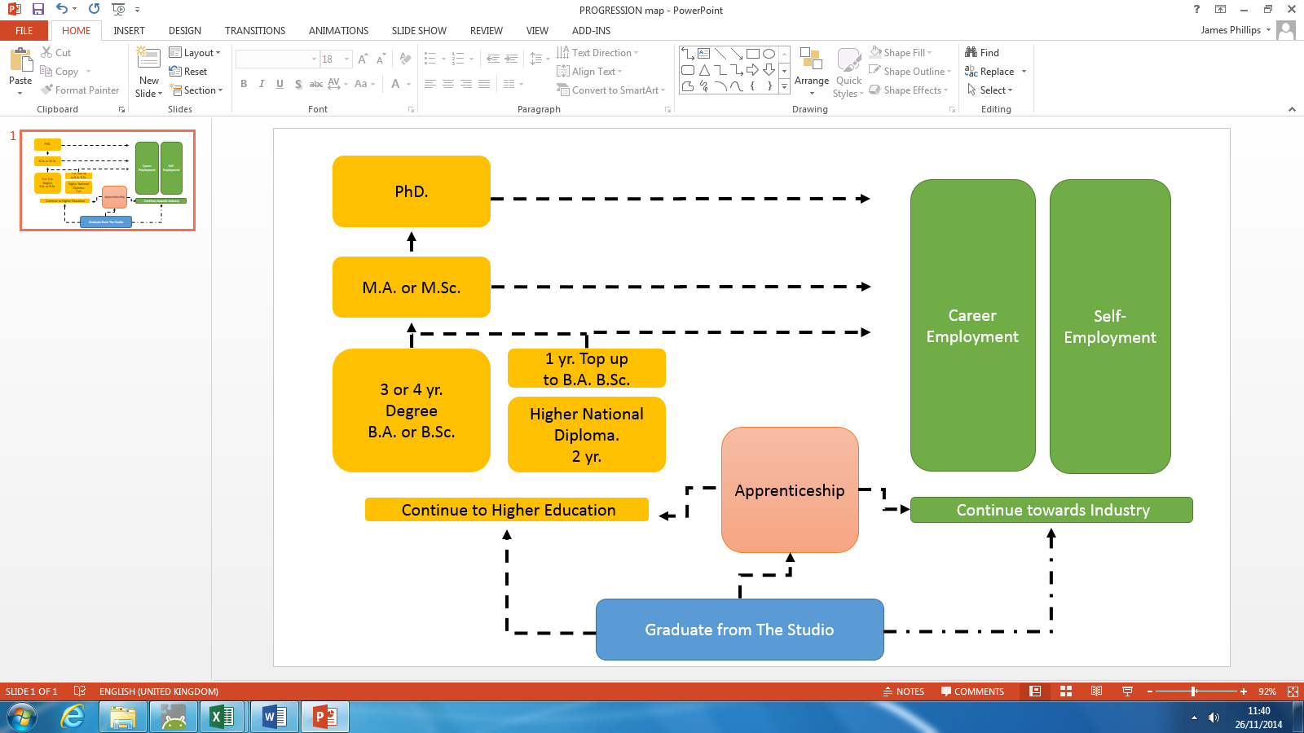

**Industry Links:**  
The Studio has excellent with Teeside University and University of Abertay Games Design departments, as well as our partner institutions e.g. Sony, Citrus Suite, Red Ninja, Milky Tea and Apposing and other leading industry professionals e.g. Ian Murphy (VFX), Mike Hanson (Psychotic Psoftware) and Si Dubavand (BBC). Also The Studio has strong links with Southport College who offer HND in Games Design and a top up year to B.A. **(accredited by University of Chester)**

**Apprenticeship Schemes:** [*www.bbc.co.uk/careers/trainee-schemes*](http://www.bbc.co.uk/careers/trainee-schemes)

[*http://www.thebigchoice.com/*](http://www.thebigchoice.com/)

[*http://www.itvjobs.com/working-here/apprenticeships/*](http://www.itvjobs.com/working-here/apprenticeships/)

[*http://mediacom.co.uk/en/careers/mediacom-apprentices.aspx*](http://mediacom.co.uk/en/careers/mediacom-apprentices.aspx)

**Potential careers and example salaries**

Games Designer: £25,000 - £50,000

Concept Artist: £35,000 - £40,000

Web Designer: £22,000 - £30,000

App Designer: £60,000 - £70,000

Games Developer: £35,000 - £50,000  
 3D Artist: £18,000 - £38,000

**Submissions**

**Deadlines**

Any work used as evidence for assignment work must be submitted by 4pm on the hand-in date, to reception staff where you will be given a submission receipt.

If submitting on paper, you must also hand in the front sheet and the plagiarism sheet from each assignment, signed to state that it is your own work being submitted. Any other accompanying paperwork should be stapled to the front sheet or collected in a plastic/paper wallet and/or folder. Your name should appear on all documents.

If your tutor has asked you to submit work electronically, you should place the work in the appropriate Google Classroom Submission box. Alternatively, your tutor may accept work by email (check if you are unsure), by Google Sites, by CD/DVD or by pen drive. Where your work consists of several files or an organised folder of work, you should put these into a single ‘zip’ file.   
  
Electronic submission of work from a logged-in school email account is counted as a declaration that it is all your unaided work. All computer files relating to this assignment must be stored on the college network.

**The Studio provides the resources needed to complete work on time.   
Problems with other computer systems are never acceptable as a reason for late work.**

**Re-submission Policy**

Only the Lead Internal Verifier can authorise a re-submission and application for resubmission must be negotiated through your assessor. In order to qualify for potential re- submission you must meet the following criteria:

* The learner has met initial deadlines or agreed deadline extension.
* The tutor judges that the learner will be able to provide improved evidence without further guidance.
* The assessor has authenticated the evidence submitted for assessment and evidence is accompanied by a signed-and-dated declaration of authenticity by the learner.   
    
  If any of these conditions are not met then re-submission cannot be authorised.

**The resubmission process requires you to provide your re-submitted evidence within 10 academic days from approval.**

**Re-Take**

Should you need to retake a second assignment brief will be given to you to complete. You will be able to achieve no higher than a **PASS** for this assignment.   
  
 If you fail the second assignment then further action will be taken.

**Online Assessments**

Any online assessments are externally assessed and are under full exam conditions.

**Types of evidence accepted**

All work submitted will be considered for assessment. Include everything with your submission as it may help describe, explain or justify your work. Reference and cite any work included that is not yours as well as providing a bibliography and/or research log to demonstrate where you have found the information. Any work that is submitted that cannot be marked will be put forward as supporting evidence.

**Example submission layout.**

Front Sheet, Plagiarism Sheet, and Resubmission Policy sheets are to be signed, stapled together and submitted with **every** assignment submission. Failure to do so will result in you **not** meeting the hand-in deadline.

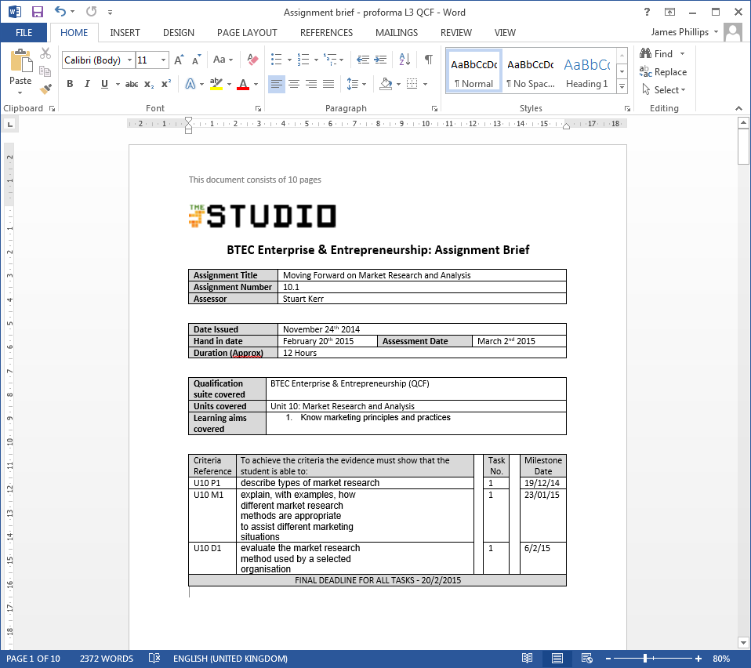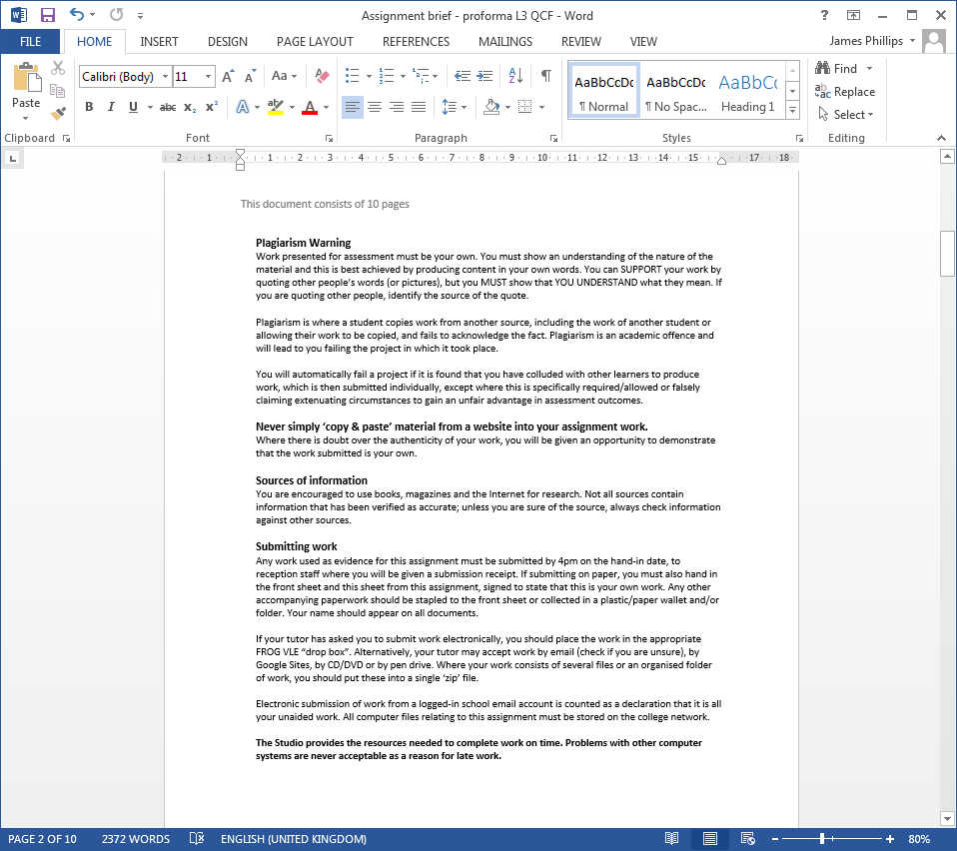

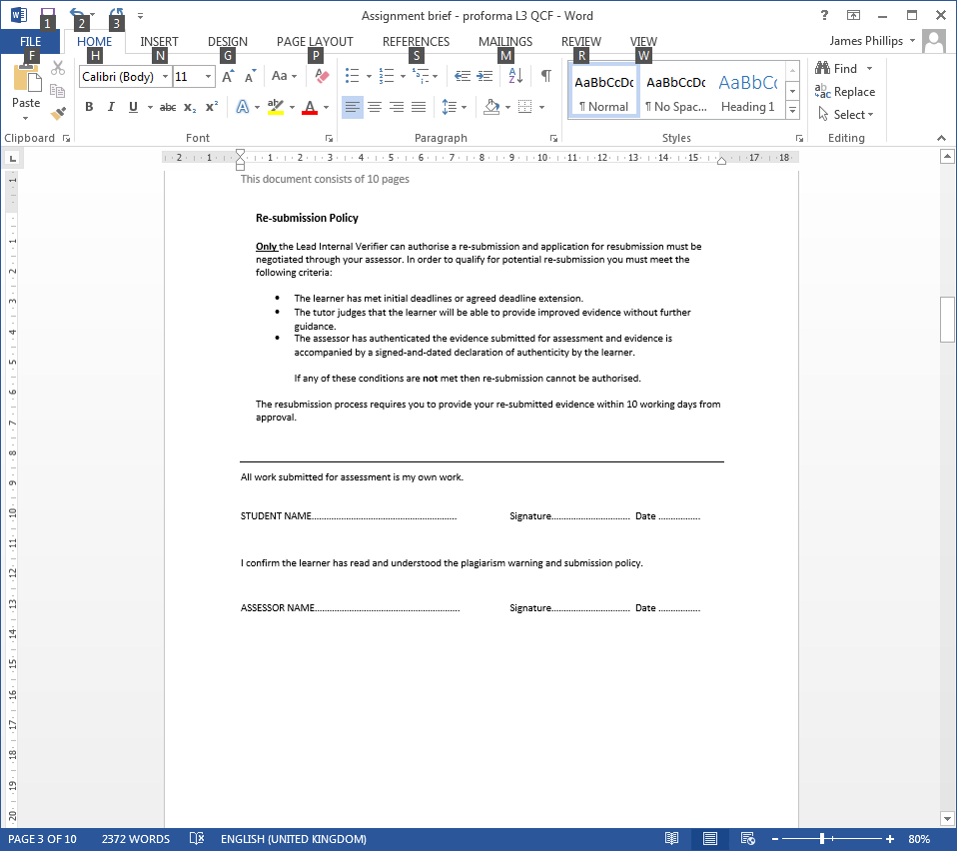

You will need to insert these sheets plus any work submitted into a plastic wallet, ensuring that your name is on everything.

You **MUST** sign your declaration of authenticity before submission. Upon receipt of your submission your tutor will look through your work and if in agreement will sign the second part. Should the assessor not agree, the plagiarism policy will take effect immediately.

**BTEC Grading Systems**

Each unit has a number of Pass, Merit and Distinction criteria linked to Learning Outcomes (LO). You will find reference to these in the form of e.g. P1 M1 D1.

Each LO must reach a minimum of pass to pass the unit and in order to gain a Unit (P, M or D) grade you must get all Learning Outcomes to be of an equal grade.

|  |  |  |  |
| --- | --- | --- | --- |
|  |  |  | Overall Unit Grade |
| P | P | P | P |
| M | M | M | M |
| D | D | D | D |

Any variation of grade will result in the lowest grade being the overall unit grade e.g.

|  |  |  |  |
| --- | --- | --- | --- |
|  |  |  | Overall Unit Grade |
| D | D | P | P |
| D | M | D | M |
| P | M | D | P |
| M | D | M | M |
| M | M | P | P |

Your final unit grades will be recorded on the tracking spreadsheet and will result in a number of BTEC points. The BTEC points are then converted into a final grade(s) and have an equivalent number of UCAS points. (See UCAS tariff points table).

**UCAS Points** **Table 2016+**

|  |  |  |  |  |  |  |  |
| --- | --- | --- | --- | --- | --- | --- | --- |
| **3 x**  **A Level**  **(equiv)** | **2 x**  **A Level**  **(equiv)** | **UCAS**  **Tariff Points** |  | **1.5 x**  **A Level**  **(equiv)** | **1 x**  **A Level**  **(equiv)** | **0.5 x**  **A Level**  **(equiv)** | **UCAS**  **Tariff**  **Points** |
| **Extended Diploma** | **National**  **Diploma** |  |  | **National**  **Foundation** | **National**  **Extended Certificate** | **National**  **Certificate** |  |
| D*D*D* |  | 168 |  |  |  |  |  |
| D*D*D |  | 160 |  |  |  |  |  |
| D*DD |  | 152 |  |  |  |  |  |
| DDD |  | 144 |  |  |  |  |  |
| DDM |  | 128 |  |  |  |  |  |
| DMM | D*D* | 112 |  |  |  |  |  |
|  | D*D | 104 |  |  |  |  |  |
| MMM | DD | 96 |  |  |  |  |  |
|  |  |  |  | D*D* |  |  | 84 |
| MMP | DM | 80 |  | D*D |  |  | 78 |
|  |  |  |  | DD |  |  | 72 |
| MPP | MM | 64 |  | DM |  |  | 60 |
|  |  |  |  |  | D* |  | 56 |
| PPP | MP | 48 |  | MM | D |  | 48 |
|  |  |  |  | MP |  |  | 36 |
|  | PP | 32 |  |  | M |  | 32 |
|  |  |  |  |  |  | D* | 28 |
|  |  |  |  | PP |  | D | 24 |
|  |  |  |  |  | P | M | 16 |
|  |  |  |  |  |  | P | 8 |

**Tracking Spreadsheet**

The tracking spreadsheet is available to you via the Student Share Drive,   
  
 and Google Classroom. It will look similar to below.

Please utilise this to keep informed of your progress on the course.

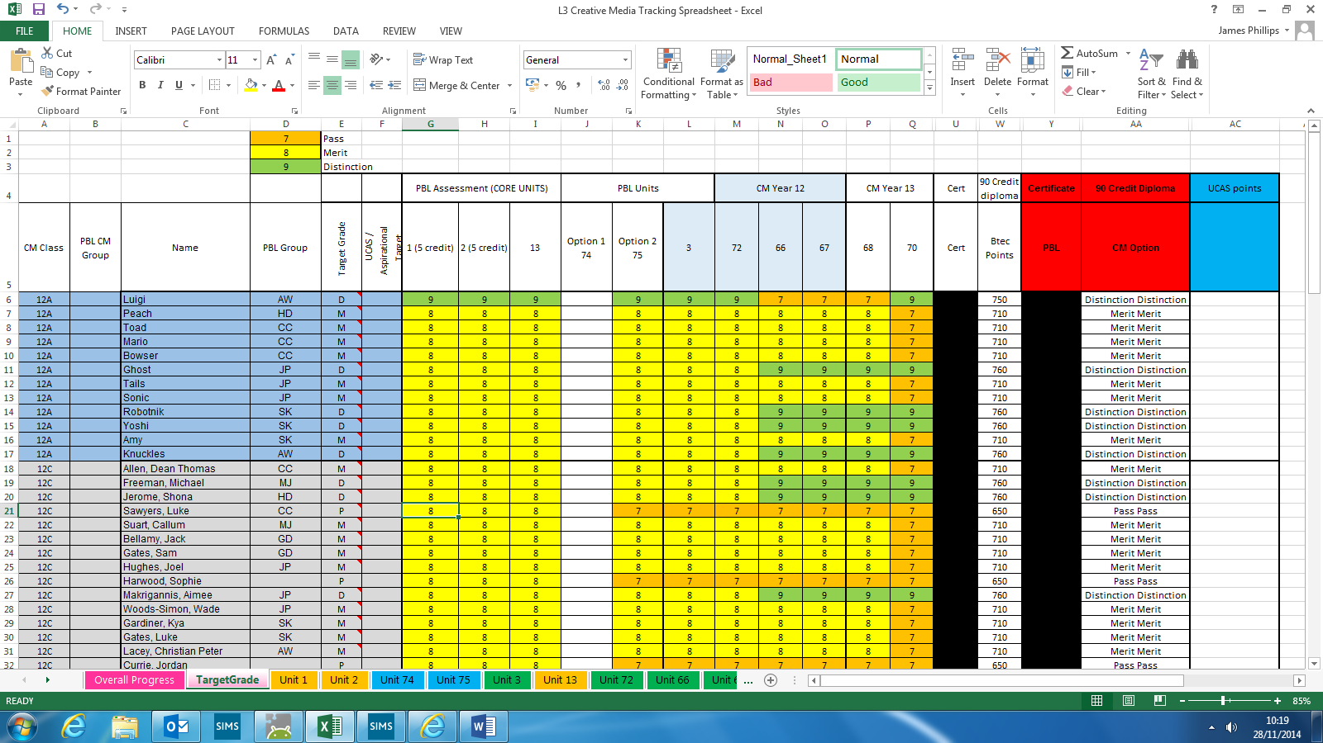

**Policies & Procedures**

**Plagiarism Warning**

Work presented for assessment must be your own. You must show an understanding of the nature of the material and this is best achieved by producing content in your own words. You can SUPPORT your work by quoting other people’s words (or pictures), but you MUST show that YOU UNDERSTAND what they mean. If you are quoting other people, identify the source of the quote.

Plagiarism is where a student copies work from another source, including the work of another student or allowing their work to be copied, and fails to acknowledge the fact. Plagiarism is an academic offence and will lead to you failing the project in which it took place.

You will automatically fail a project if it is found that you have colluded with other learners to produce work, which is then submitted individually, except where this is specifically required/allowed or falsely claiming extenuating circumstances to gain an unfair advantage in assessment outcomes.

**Never simply ‘copy & paste’ material from a website into your assignment work.**

Where there is doubt over the authenticity of your work, you will be given an opportunity to demonstrate that the work submitted is your own.

**Sources of information**

You are encouraged to use books, magazines and the Internet for research. Not all sources contain information that has been verified as accurate; unless you are sure of the source, always check information against other sources.

**Submitting work**

Any work used as evidence for this assignment must be submitted by 4pm on the hand-in date, to reception staff where you will be given a submission receipt. If submitting on paper, you must also hand in the front sheet and this sheet from this assignment, signed to state that this is your own work. Any other accompanying paperwork should be stapled to the front sheet or collected in a plastic/paper wallet and/or folder. Your name should appear on all documents.

If your tutor has asked you to submit work electronically, you should place the work in the appropriate FROG VLE “drop box”. Alternatively, your tutor may accept work by email (check if you are unsure), by Google Sites, by CD/DVD or by pen drive. Where your work consists of several files or an organised folder of work, you should put these into a single ‘zip’ file.   
  
Electronic submission of work from a logged-in school email account is counted as a declaration that it is all your unaided work. All computer files relating to this assignment must be stored on the college network.

**Re-submission Policy**

**Only** the Lead Internal Verifier can authorise a re-submission and application for resubmission must be negotiated through your assessor. In order to qualify for potential re-submission you must meet the following criteria:

* The learner has met initial deadlines or agreed deadline extension.
* The tutor judges that the learner will be able to provide improved evidence without further guidance.
* The assessor has authenticated the evidence submitted for assessment and evidence is accompanied by a signed-and-dated declaration of authenticity by the learner.   
    
  If any of these conditions are **not** met then re-submission cannot be authorised.

The resubmission process requires you to provide your re-submitted evidence within 10 working days from approval.

**The Studio provides the resources needed to complete work on time. Problems with other computer systems are never acceptable as a reason for late work**

I.V. Procedures

Internal Verification (I.V.) is when another appropriate member of staff checks the assessor grades are accurate and follows the BTEC guidelines and criteria. A sample of at least 25% pieces of work per assignment submission is required by Edexcel and equal distribution of work by each student will be looked at.

S.V. Procedures

Standards Verification (S.V.) is when an external assessor visits The Studio   
(or is sent digitally) a specific sample of work from each unit undertaken. The amount of work addressed and learners chosen is defined by the Standards Verifier.

Exams Policy

You may be required to undertake exams, controlled assessments or work under exam conditions. If you have any specific requirements or equipment for your assessment/exam your BTEC tutor or Coach must be informed as soon as possible in order to best accommodate your needs. If this information is delayed then it may be detrimental to your academic achievement.

**Appeals**

Procedures

If you require an extension to your deadline you can apply for it by completing a Deadline extension request or Extenuating Circumstances form and submitting it to your tutor along with any supportive documentation. Your application will then be discussed with appropriate members of staff and you will be informed of the result in writing.

Contesting grades

Where you have a dispute over the grade awarded, you have the right to ask for your work to be included within (or in addition to) the I.V. sample. The I.V. will then follow the I.V. procedure and will inform you of the result in writing.

Extensions

Where you have a temporary unexpected circumstance that means you are unable to complete a particular assignment on time you may apply for an extension for up to ten working days.

Examples of unexpected circumstances may include short-term illness, caring for a sick relative, unexpected personal difficulties. You should complete and submit an [extension request form](https://www.uclan.ac.uk/students/study/examinations_and_awards/files/Extension_Request_Application_Form.docx), with any supporting evidence, to your School office.

You must submit the request before the submission date. Extensions cannot be given retrospectively. The Studio will tell you whether the extension has been granted, normally within one working day of your request. The Studio will tell you the new submission date in writing. If your request is refused you must complete your assignment by the original submission date.

Extenuating circumstances

During your studies you may have serious personal, medical or family problems that are outside your control and are negatively affecting your academic performance; If you believe that what is happening to you is affecting your ability to prepare or participate in your studies, or complete assessments, then it is your responsibility to let The Studio know what is happening as soon as possible.

Where this occurs The Studio will provide appropriate support and, depending on the nature of the problem, you can apply for an extension to an assignment submission date.

Extenuating Circumstances include situations where you have experienced:

• Significant illness or injury  
• The death or critical/significant illness of a close family member/dependent  
• Family crisis or major financial problems leading to acute stress  
• Absence for jury service or maternity, paternity or adoption leave  
• A criminal act where you have been a victim.

Although this may be a difficult time for you, if you are applying for Extenuating Circumstances it is in your own interest to act as early as possible. Where possible you must apply no later than 3 days after any examination or assessment submission date. Do not wait until you receive your assessment results to submit a claim. It is in your own interests to submit the claim as soon as possible.

Evidence is required to substantiate your submission. If this is not available at the time you complete the application form, please make it clear what evidence you will be able to supply and when it will be available. You must submit the evidence as soon as possible. The sooner evidence is provided the earlier a decision will be made and support provided.   
  
For guidance, please see the table below for examples of the types of evidence you may submit.

| Extenuating Circumstance reason | Example of type of evidence |
| --- | --- |
| Significant illness or injury to self | Medical certificate or prescription  Hospital letter or note  Appointment card |
| Death or critical/significant illness of a close family member/dependent | Death certificate  Obituary notice  Newspaper article  Medical certificate/hospital letter or note |
| Family crisis or major financial problems leading to acute stress | Documents relating to the issue  Statement from independent professional,   including counsellor, victim support or legal advisor |
| Absence for jury service or maternity, paternity or adoption leave | Official letters/documentation |
| Victim of crime | Police report  Statement from independent professional,   including counsellor, victim support or legal advisor |
| Work commitments (in rare cases) | Letter from employer |

Reasons that do not constitute grounds for the granting of Extenuating Circumstances:

* Everyday issues and occurrences such as transport problems, time management, childcare, holidays, moving house
* Everyday illnesses such as colds and headaches
* Religious observance or obligations
* Extended periods of international travel during term time
* Disability or learning difficulty

**Equipment List**

To encourage good habits we expected each student to have and maintain the following equipment at all times from the start of the course:

|  |  |
| --- | --- |
| Essential | Non-Essential |
| Pen(s)  Pencil(s)  Eraser  Sharpener  Ruler  Coloured Pencils  Fine liners/Felt tip pens  Note book/Jotter/Moleskin A5/A6  Pen Drive with Keychain (32Gb or hire)  Headphones | Computer Mouse  Graphics Tablet + Pen  Mobile Phone (SMART) with Apps (free)  Google Drive  Google Classroom  Gmail  WamEdu  Slack  Trello  YouTube  USB Data Cable (if using mobile phone)  Laptop or Desktop with internet access. |

**Reading List**

It is important that you not only attend class and undertake your assignment work but that you also read around the subject for a more holistic view of the digital creative industries. It is important for a number of reasons especially for that of literacy skills, the ability to transfer concepts and technical knowledge and creative wonder. Below is a small suggested list of Books, Websites, Tutorials and Twitter Feeds for you to look at to help familiarise yourself with concepts, language and some of the opportunities that might be available.

Books:

# Human-computer Interaction - Alan Dix - 978-0132398640

The Art of Game Design: A Book of Lenses – Jesse Schell ISBN 978-1466598645

# Game Design Workshop: A Playcentric Approach to Creating Innovative Games – Tracy Fullerton ISBN 978-1482217162

Websites:

Scott McCloud <http://scottmccloud.com/1-webcomics/zot/index.html>

BBC Click <http://www.bbc.co.uk/programmes/b006m9ry>

BBC News (Technology) <http://www.bbc.co.uk/news/technology>

Gamasutra <http://www.gamasutra.com>

Tutorials

**C# and Unity Tutorials**

<https://unity3d.com/learn/tutorials/topics/scripting/coding-unity-absolute-beginner>

**Unity**

<https://unity3d.com/learn/tutorials>

**Construct 2**

<https://www.scirra.com/tutorials/top/page-1>

Twitter Feeds:

Shaun McInernery @LPSPrincipal

The Studio Liverpool @lpoolstudio

MINT Games @MintGamesUK

Ripstone @RipstoneGames

TechCrunch @TechCrunch

Rockstar @RockstarGames

Catalyst @Catalyst_Games

UVGames @UV_Games

**YouTube**

The ability to find all the relevant (and interesting) videos that surround or support the course can be found here at my YouTube channel under the playlist section.

<https://www.youtube.com/channel/UCxOZGJNFI2XIHLIPtJYBAxQ>